Early clinical diagnosis of heart ischaemic disease.

This brief article is really interesting in order to recognize at the bed-side heart ischaemic disease before whatever pathology occurs. Moreover, it is well known for many years that patients with coronary artery disease (CAD) may have no symptoms at all and that the electrocardiographic feature of ischaemia may be induced by exercise without accompaning angina (1). (For further information: See “Cardiopatia Ischemica, anche silente, diagnosticata clinicamente”, in Home-Page, italian version).
In other words, we need a clinical tool reliable in detecting CAD, even clinically silent. You can read my clinical answer,I illustrated some years ago with the aid of biophysical semeiotics (1). I think surely that one method is "Myocardial Ischaemic Preconditioning", described elsewhere(1). Doctor has to know, at least, the auscultatory percussion of the stomach, described also in old academic books. Briefly, in healthy individuals digital pressure of mean intensity, applied upon heart cutaneous projection area, brings about the so-called gastric aspecific reflex (= in the stomach, fundus and body are dilated; on the contrary, antral-pyloric region contracts) after an age-dependent latency time of 6-7 sec.(Fig.1)

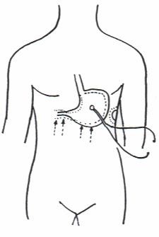
Fig. 1
A second, successive evaluation after an interval of 5 sec.exactly, provokes the identical reflex, but after 8-9 sec.: physiological myocardial preconditioning.
On the contrary, in patients involved by CAD, even silent, latency time persists identical in both evaluations or become clearly lower in the second one, in relation with disease seriousness.
Of course, biophysical preconditioning evaluation, really more complex than it appears in the above description, can be applied to all others biological systems, with favourable influences on primary prevention and diagnosis. (For further information, See: Bibliography in Home-Page).
1) Stagnaro-Neri M., Stagnaro S. Deterministic Chaos, Preconditioning and Myocardial Oxygenation evaluated clinically with the aid of Biophysical Semeiotics in the Diagnosis of Ischaeemic Heart Disease even silent. Acta Medica Mediterranea 13, 109-116, 1997.

